

**E. U. A SILVA**

SID : 1938086

**PocketDoc**

B. Sc. (Hons) Computer Science & Technology Undergraduate Thesis Report

Department of Computer Science & Technology Faculty of Creative Arts, Technologies & Science Supervisor: Dr.Yasas Jayaweera

### 2020

# **Abstract**

Viruses have always played a part from the formation of the earth to its evolution and will to its very destruction. Among these viruses, epidemic is no entertaining subject matter to discuss. However, the risk of infection in situations of an epidemic significantly rises day after day until a vaccine is produced. The fear of infection increases day by day, the general public tends to seek medical consultation without proper preventive measures endangering our defense, the medical personnel against these outbreaks.

The proposed system intends to bridge the gap between the healthcare personal and the citizens of a country and doing so minimizing the risk of exposure in an epidemic. The proposed system intends achieve this by allowing healthcare authority to create customized questionnaires which will helps to identify when an individual has a higher probability of being infected and taking necessary precautions to locate and isolate further exposure.

Key Words: Epidemic, Questionnaire, Medical personal, Citizens

# **Acknowledgment**

I would like to take this opportunity to thank my supervisor Dr.Yasas Jayaweera for taking time to look into my project and providing guidance throughout the project. Secondly, I like to thank Ms.Gayana Fernando, the lecturer in charge of the Undergraduate Project for allocating her valuable time to guide me through the necessary documentation and providing valuable suggestions on further improvement.

Special gratitude goes to my parents and my sister for being immense support to complete this research and encouraging me to go the extra mile to succeed.

Also, my colleagues Vishwa Gunarathne, Oshadee Amarasinghe for their tremendous support and encouragement to fulfill this endeavor.

And a special thank-you goes to my supervisor at work, Mr. Sameera Roshan for his monumental support and guidance.

**Dedication**

I would like to dedicate this project to my parents, sister, to my supervisor Dr.Yasas Jayaweera and to the lecturer in charge Ms.Gayana Fernando.

**Table of Contents**

**Abstract** i

**Acknowledgment** ii

**Dedication** iii

**List of Figures** vi

**List of Tables** vii

**List of Abbreviations** viii

**1.** **Introduction** 1

**1.1** **Project Background** 1

**1.2** **Project Aims and Objectives** 2

***1.2.1*** ***Aims*** 2

***1.2.2*** ***Objectives*** 2

***1.2.3*** ***Features*** 2

**1.3** **Project Realization** 3

***1.3.1*** ***Technical Feasibility*** 3

**1.4 Structure of the report** 3

***1.4.1 Chapter 1: Introduction*** 4

***1.4.2 Chapter 2: Literature review*** 4

***1.4.3 Chapter 3: Methodology*** 4

***1.4.4 Chapter 4: Results and Discussion*** 4

***1.4.5 Chapter 5: Evaluation*** 4

***1.4.6 Chapter 6: Conclusion*** 5

**2.** **Literature Review** 6

**2.1** **Introduction** 6

**2.2** **Diseases** 6

***2.2.1*** ***Bacillary Dysentery (shigellosis)*** 6

***2.2.2*** ***Dengue*** 7

***2.2.3*** ***Coronavirus (COVID-19)*** 7

**2.3** **Similar Applications** 7

***2.3.1*** ***ODoc – Video Consultations*** 7

***2.3.2*** ***eChannelling*** 8

***2.3.3*** ***Doc 990*** 9

***2.3.4*** ***NawalokaCare*** 10

**2.4** **Research Significance** 11

**3.** **Methodology** 12

**3.1 Introduction to methodology** 13

**3.2 Planning** 14

**3.3 Requirement Analysis** 17

***3.3.1 Primary Data Gathering*** 17

**3.4 Design** 22

***3.4.1 System design – Use case Diagram*** 22

***3.4.2 System Designs – Authentication Flow Chart*** 23

***3.4.3 System Designs – Questionnaire Submission Flow Chart*** 24

***3.4.4 System Designs – P2I Algorithm Flow Chart*** 25

***3.4.5 System Designs – Sequence Diagram*** 26

***3.4.6 System Designs – Data Model Diagram*** 27

***3.4.7 High Level Architecture*** 28

***3.4.8 Interfaces of the proposed system*** 29

***3.5 Implementation*** 33

***3.5.1 Technologies Used*** 33

***3.5.2 Code segments*** 39

**4. Results and Discussion** 57

**4.1 Structure of Testing** 57

**4.2 Testing Methods Used** 57

**4.3 Test Plan and Test Cases** 57

**5. Evaluation** 72

**5.1 Evaluation Overview** 73

***5.1.1 Survey Overview of PocketDoc-MyCare*** 73

***5.1.2 Survey Overview of PocketDoc-PSync*** 74

**6. Conclusion** 75

**6.1 Conclusion** 75

**6.2 Lessons Learned** 75

**6.3 Limitations** 76

**6.4 Future Work** 76

**References** 78

**Appendix A – Project Poster** 80

**Appendix B – Evaluation forms (MyCare & PSync)** 81

**Appendix C : Questionnaire** 83

# **List of Figures**

Figure 1: eChannelling Application (eChannelling, 2020) 11

Figure 2: Doc 990 Application (Doc 990, 2020) 12

Figure 3: NawalokaCare Application (NawalokaCare, 2020) 13

Figure 4: Prototype Model (Prototype Model, 2020) 16

Figure 5 : Work Breakdown Structure 17

Figure 6: Gantt Chart 18

Figure 7: Immediate response in an epidemic (Sample Survey 2020) 19

Figure 8 : Precautionary measurements taken when visiting a medical institution (Sample Survey 2020) 20

Figure 9 : Responses to introducing the proposed system (Sample Survey 2020) 21

Figure 10 : Approval to share location (Sample Survey 2020) 22

Figure 11 : Preference to other services provided (Sample Survey 2020) 23

Figure 12 : Use Case diagram of the proposed system 24

Figure 13 : Authentication flow of the proposed system 25

Figure 14 : Questionnaire submission flow of the proposed system 26

Figure 15 : P2I algorithm flow chart 27

Figure 16 : Sequential flow of the proposed system 28

Figure 17 : Data models of the proposed system 29

Figure 18 : High level architecture of the proposed system 30

Figure 19 : Platform infrastructure of the proposed system 30

Figure 20 : Interfaces of the PocketDoc-MyCare mobile application 32

Figure 21: Interfaces of the PocketDoc - PSync web application 34

Figure 22 : MVC architecture (MVC Architecture in 5 minutes: a tutorial for beginners, 2020) 36

Figure 23: Firebase console of PocketDoc system 37

Figure 24 : Firestore database 38

Figure 25 : Firebase Cloud Function dashboard 38

Figure 26 : Firebase Cloud Function console 39

Figure 27 : Firebase Storage 39

Figure 28 : GitHub repository 40

Figure 29 : Testing methods used 59

Figure 30 : Evaluation carried out by general public (Evaluation Survey 2020) 75

Figure 31 : Evaluation carried out by medical students (Evaluation Survey 2020) 76

# **List of Tables**

Table 1 : Comparison table 12

Table 2 : Test plans 58

Table 3 : PocketDoc test cases 59

# **List of Abbreviations**

1. WBS – Work breakdown structure
2. SDLC – Software development life cycle
3. WHO – World health organization
4. IDE – Integrated development environment
5. GCP – Google Cloud Platform
6. ML – Machine Learning
7. P2I – Patient Imperativeness Identifier
8. DMD – Data Model Diagram
9. **Introduction**
   1. **Project Background**

Manifestation of an illness in a region or community with an unusual behavior is classified as an epidemic (WHO | Definitions: emergencies, 2020), in brief a natural disaster. Sri Lanka has encountered over 9 virus outbreaks in its long line of history (*Communicable Disease Epidemiological Profile Sri Lanka*, 2020). Sri Lanka is classified as a developing country and yet has had its fair share of sharpening brilliant minds towards success.

However, the human mind is a sophisticated instrument to entirely grasp its underlying concepts. Scientists devote a tremendous effort to observe, understand and categorize these concepts of the human mind. Careful observation has led to significant progress in understanding the mechanism behind human behavior. Late theories indicate that emotional impulses act as triggers to alter human behavior back and forth. Physiologists have been able to identify most of these triggers and classify them accordingly. After all, these so-called triggers are bits of data which can be used to build predictive models to classify human behavior. However, it is much more complicated than using unclassified bits of data to predict human behavior. Scientists and physiologists are working relentlessly to increase the accuracy of these predictions and minimize human error in the process. To support this claim, Sri Lanka is presently developing a program known as ‘Sati-Pasala’ backed by London Stock Exchange Group (LSEG) to build a predictive model to improve the mindfulness of youth through customized questionnaires

The proposed system, PocketDoc intends to bridge the gap between two most important questions during an epidemic. One, how can the medical staff be protected from getting exposed to the virus. Second, how can technology be used to overcome the above problem.

The solution is to develop a questionnaire-based cross-platform system with the help of discoveries made by physiologists relating to the human mind and using that to determine the probability of infection that an individual has based on how he/she answers the questions. And if found to have a higher probability then notifying the national healthcare authority to carry out further actions.

* 1. **Project Aims and Objectives**
     1. ***Aims***

To develop a cross-platform system for Sri Lankan citizens to determine if they have a probability of already being infected by a prevailing virus outbreak and for the health care authorities to make citizens aware of any such virus outbreaks and get notified if any individual has a high probability of already being infected.

* + 1. ***Objectives***

The core objective of the proposed system is to help Sri Lanka prepare and overcome a virus outbreak with more effective use of technological resources in hand minimizing the risk for exposure to medical staff.

* To develop a cross-platform mobile application to make Sri Lankan citizens aware of the prevailing virus outbreak and its symptoms.
* To provide a probability-based solution to identify whether an individual has a probability of already being infected or not through the mobile application.
* To develop a web-based application for health care authorities to add new information of epidemics in Sri Lanka.
* To inform health care authorities and locate an individual if he/she has a higher probability of already being infected through the web-based system.
* To develop an algorithm to identify and locate such infected individuals.
  + 1. ***Features***

The proposed system will be used by two user groups, health care authorities and the general public. Following are the features that will be available for each user group.

1. Health Care Authority

* To store information regarding the Sri Lankan virus outbreaks.
* To create questionnaires to determine the health status of the general public.
* To locate an infected individual identified through the system.
* To authorize new members and revoke permission of existing members.

1. Public Users

* To register as a new user or login as an existing user.
* To view symptoms and relevant information of a prevailing virus outbreak.
* To check whether he/she has already been infected by the virus or not.
  1. **Project Realization**

In order for the proposed system to begin planning and implementation, the system had to undergo a technical feasibility study.

### ***Technical Feasibility***

The proposed system is based on a web application to be used by healthcare authority and mobile application to be used by Sri Lankan citizens. The symptoms, precautions and statistics of the epidemic needed to be updated real-time, therefore Google’s Cloud Firestore database was selected. To improve the in-app security and support future development, custom APIs had to be implemented, therefore Firebase Cloud Functions was selected since it had direct support to other Firebase services such as Cloud Firestore. The algorithm to determine the criticalness of an individual was also planned to be implemented in a Firebase Cloud Function since the cost of Machine Learning (ML) at early stages was too expensive. Angular was selected to build the web application due to its component-oriented architecture and its capability to update content real-time on web pages. NativeScript was selected to build the cross-platform mobile application since it had support for Angular integration.

## **1.4 Structure of the report**

The thesis report contains 6 core chapters.

### ***1.4.1 Chapter 1: Introduction***

This chapter provides the reader an overview of the proposed system. What is the issue in hand and how the proposed system intends to overcome this issue. Chapter also provide a background to the research and feasibility studies conducted relating to the proposed system.

### ***1.4.2 Chapter 2: Literature review***

This chapter consists of the findings discovered from research papers, journals, and other materials relevant to the proposed system. It also includes the background for why the proposed system is significantly important to address the issue in hand. Furthermore, it also specifies the existing systems present as the proposed system and critical analytics of them.

### ***1.4.3 Chapter 3: Methodology***

The chapter demonstrates the methodology that was used to develop the system and the discussion on why the mentioned methodology was selected and tasks carried out through each phase. Furthermore, in-depth information about the requirement gathering, planning, designing and implementation are broadly discussed.

### ***1.4.4 Chapter 4: Results and Discussion***

The chapter includes the types of tests and the related test cases that were carried out after implementing the proposed system. Evidence of the operational system will also be included in this chapter.

### ***1.4.5 Chapter 5: Evaluation***

This chapter contains the discussions relating to the evaluations process carried out and visualized feedback charts of the proposed system.

### ***1.4.6 Chapter 6: Conclusion***

This chapter explains the significance of the proposed system and its present limitations and how they can be resolved along with what additional implementations could be made to improve its value.

1. **Literature Review**

## **Introduction**

This chapter will be focusing on the content in detail related to the proposed system. The overall chapter gives the reader a better understanding on why the proposed system is important based on its content. Starting from the prevailing problem, secondly, identifying what other systems has been introduced to address the issue in hand, and finally, how the proposed system could be used to improve the existing solutions and provide a foundation to base future solutions on.

Sri Lanka, a country with population of approximately 21.4 million ("Sri Lanka Population (2020) - Worldometer", 2020) has faced more than one epidemic in its long line history. In times of these, the health authority performs countless number of tests to gain a deeper understanding of the source of the outbreak. Tough these tests carried out lays the foundation in producing a vaccine, the methods used to test the general public are much exposed in nature. To minimize the risk of exposure, medial staff needs a way to identify whether an individual has a probability of being infected or not in the early stages of an outbreak, And the proposed system would be the foundation to that.

* 1. **Diseases**

### ***Bacillary Dysentery (shigellosis)***

Epidemic profile of Sri Lanka maintained by WHO (World Health Organization) as of 2010 specifies (Communicable Disease Epidemiological Profile Sri Lanka, 2020) shigellosis is categorized as an infectious disease which is caused by a group of bacteria named as Shigella. Shigella is transmitted through remains of digested food, orally and in most common cases through contaminated food or water. Typically, the infected are associated with fever, vomiting, nausea, diarrhea, rectal pain, and stomach cramps starting typically after a day or two from being exposed to the bacteria. In uncomplicated cases disease is found to resolve in 4-7 days and usually limited to the individual. Fatality rates can be high as 15 percent in complicated cases. Testing is carried out using stool samples to determine the infection of shigellosis.

In 2006, Sri Lanka reported its highest number of Shigellosis cases in Ampara, Moneragala, Vavuniya and Ampara districts. The highest were identified in November and December, on average of 1000 per month and the lowest cases were found in March to May, on average 300-400 per month.

As per the records of 2010 maintained by WHO, several vaccines were developed but none were found effective.

### ***Dengue***

Mosquito-borne infectious disease, which spreads to humans by a bite of an infected mosquito (Dengue | CDC, 2020). Symptoms typically manifest within 4-13 days after the infection with three phases, febrile, critical and recovery. The virus is reported to have symptoms of nausea, vomiting, rash, aches and pains and high fever. Dengue virus is not only found in Sri Lanka but approximately 100 counties and 40 percent of the world’s population are reported to be in areas with high risk of dengue virus.  Testing is carried out using polymerase chain reaction (PCR) testing to determine the infection (Communicable Disease Epidemiological Profile Sri Lanka, 2020).

Dengue is not reported to spread directly from person-to-person interaction, but the mode of transmission has been found as human-mosquito-human.

In the year 2006, Sri Lanka reported total of 5646 cases along with 46 deaths. Sri Lanka’s healthcare authority marked Colombo and 8 more major cities as areas with high risk of infection.

Dengue virus is found be life-threatening according to the phase of infection, and WHO states that a vaccine has not yet been developed to this date.

### ***Coronavirus (COVID-19)***

Coronavirus also known as COVID-19, an infectious disease which originated from Wuhan, Hubei Province China (Coronavirus Disease (COVID-19), 2020) has spread across over more than 180 countries including Sri Lanka. The disease is reported to indicate symptoms within 14 days of infection which includes fever, dry cough, tiredness, sore throat, and difficulty in breathing. Testing is carried out using PCR testing to determine the infection (Rolling updates on Coronavirus disease (COVID-19), 2020).

Most recent statistics of coronavirus spreading through Sri Lanka indicates a death toll of 9, 1089 confirmed cases and 674 recoveries.  (Coronavirus disease 2019 (COVID-19) - Situation Report – 24.05.2020 – 10.00am, 2020)

* 1. **Similar Applications**

### ***ODoc – Video Consultations***

oDoc is commercial mobile application designed for small to large scale organization to provide their employees with remote medical care facilities through video consultations. The application is developed to bridge the gap between patient and doctor through reserving online appointments and prescribing medicine after consultation. Once subscribed, oDoc also offers several facilities to the employee’s family.

Screenshot Image 

* Features of oDoc
* Access to a variety of medical experts
* Availability of unlimited text, audio, video consultation
* Provision of prescriptions from authorized medical experts
* Limitations of oDoc
* Services of oDoc are limited to the workforce
* Video consultations requires larger bandwidth which is quite costly in Sri Lanka

### ***eChannelling***

eChanneling in a mobile application developed by e-Channelling PLC to contact experts form over 140+ private medical institutions in Sri Lanka. eChanneling provides its users with ability to reserve medical appointments simply by searching doctor’s name or the medial institution and track user’s reservation history processed through eChanneling.



* Features of eChanneling
* Access to a variety of medical experts
* Track the reservation history
* Provides facility to place orders by providing prescription
* Access to remote video consultation from medical experts
* Limitations of eChanneling
* Services provided by eChanneling does not possess a payment gateway to finalize reservations
* Sri Lankan health care authority is not notified of any medicine requested through prescriptions
* Poor user experience due to lack of proper navigation established within the application
* Video consultations requires larger bandwidth which is quite costly in Sri Lanka
  + 1. ***Doc 990***

Doc 990 is developed by Dialog Axiata which provides a variety of services to its users including a payment gateway to finalize reservations to seek medial consultation. Doc 990 is frequently updated to provide its users with the best services and has over 1 million downloads.

Screenshot Image 

* Features of Doc 990
* Access to a variety of medical experts
* Services extended to handle a wide range of payment options
* Track reservation history
* Notifications services to keep track of the latest appointments
* Limitations of Doc 990
* Services are limited to day-to-day operations thus providing awareness of an outbreak is not available
* Services provided are limited to offline consultation of medical experts (no video consultations are provided)
  + 1. ***NawalokaCare***

NawalokaCare is a commercial mobile application provided by Nawaloka Hospitals PLC. The application provides a wide range of services including statistical of the present outbreak, coronavirus. NawalokaCare is still in development phase and a beta version has been uploaded to Google Play Store.

Screenshot Image 

* Features of NawalokaCare
* Access to medical experts registered with Nawaloka Hospitals PLC
* Availability of statistical data related to an outbreak
* Facilities to contact medical experts though chat messages and video calls
* Integration of Google fit to track user wellness
* Access to online pharmacies under Nawaloka Hospitals PLC
* Limitations of NawalokaCare
* Outbreak’s statistical data is limited to recovered, dead and total cases
* Pool of medical experts are limited to experts only registered with Nawaloka Hospitals PLC
* Services provided does not include a payment gateway to finalize reservations
  1. **Research Significance**

The health authority bears a significant burden in having to oversee country’s necessities while produce vaccine. Minimizing human to human interaction is one of many factors when it comes to any epidemic. According to the findings, most applications provides remote consolation of medical experts which in result reduces the risk of exposure. However, these services provided are not without their drawback. None of these services are provided by the public sector, therefore patients health information is not available to healthcare authority which could result in reducing the chances of epidemic spreading.

Therefore, the goal of this research is to establish a platform between the healthcare authority and general public. This is done by implementing questionnaire-based system which could identify the criticalness of an individual by analyzing the answers provided by him/her.

Below tables demonstrates a comparison between the functionalities and limitations of existing applications against the proposed system’s functionalities.

Table 1 : Comparison table

|  |  |  |  |  |  |
| --- | --- | --- | --- | --- | --- |
| Features | oDoc | eChanneling | Doc 990 | NawalokaCare | PocketDoc (Proposed system) |
| Cross-platform availability | Checkmark | - | - | - | Checkmark |
| Provision on statistical data regarding a prevailing epidemic | - | - | - | Checkmark | Checkmark |
| Provision of information regarding operational medical centers during an epidemic | - | - | - | - | Checkmark |
| Steps implemented to minimize virus exposure from patients to medical staff | Checkmark | Checkmark | - | Checkmark | Checkmark |
| Above implemented steps with minimum cost to users | - | - | - | - | Checkmark |
| Patient status notified directly to healthcare authority to better understand the outbreak source | - | - | - | - | Checkmark |

# **3.** **Methodology**

Optimal allocation of resources at disposal is the key in producing a quality product within the planned budget. To properly manage these scarce resources, a methodology can be used. A Methodology will help ease the overall complication and contribute to properly analyzing, designing, implementing, and maintaining a system after development. To ease this complication, a methodology breaks down the overall process into sub tasks thus making it easier to evaluate each sub tasks individually.

## **3.1 Introduction to methodology**

To develop the proposed system, one of the most known Software Development Life Cycle models (SDLC) known as prototyping model was used. Prototyping model is widely used and most effective in cases where the end product is user oriented (T, 2020). The proposed system was developed under a selected model so that the general public could actively engage in the development process thereby reducing the risk failure from unsatisfactory. Active engagement from end users also helps them to get familiar with the product from the very early stages of development.

Advantages encountered of using prototype model during implementation

* Bugs and inefficiencies were detected at early stages of the implementation
* End users familiarizing with the proposed system at early stages had a positive impact on improving the final product
* Lacking functionalities were identified before the later stages of the implementation

Drawbacks encountered of using prototype model during implementation

* Every prototype release increased the complexity of the proposed system scope, which was not accounted for at the beginning of the implementation

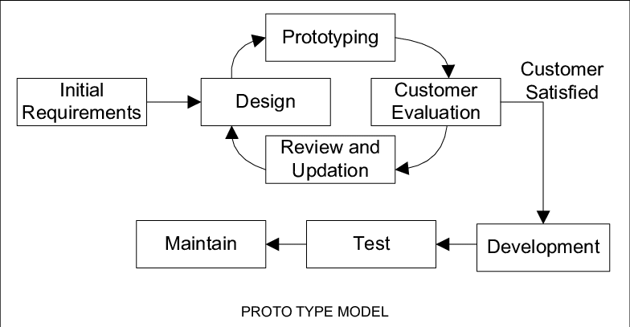

Figure 5: Prototype Model (Prototype Model, 2020)

## **3.2 Planning**

Planning is the key behind any successful system and to assist the delivery of the proposed system on time, proper planning was crucial. To ease the complexity and smoothen the planning process, work breakdown structure (WBS) and Gantt chart was created.

WBS was used to simplify the structure of the overall system into a collection of sub tasks. To design the WBS for the proposed system, overall structure was divided into 7 main tasks.

* Planning – The task consisted of performing a feasibility study to better understand the nature of the proposed system and how it can be achieved
* Requirement Gathering – Research was performed to gain a deeper knowledge on background of the proposed system, and literature review was drafted as the final outcome
* Design – Task consisted of analyzing the identified requirements and settling on a system architecture to proceed. During this task, functional flow, use case, sequence, and data model diagrams were designed
* Implementation – During this task, implementation was carried out as prototypes as per the selected SDLC model.
* Testing – Research was carried out on what and how should the system be tested and was carried out accordingly.

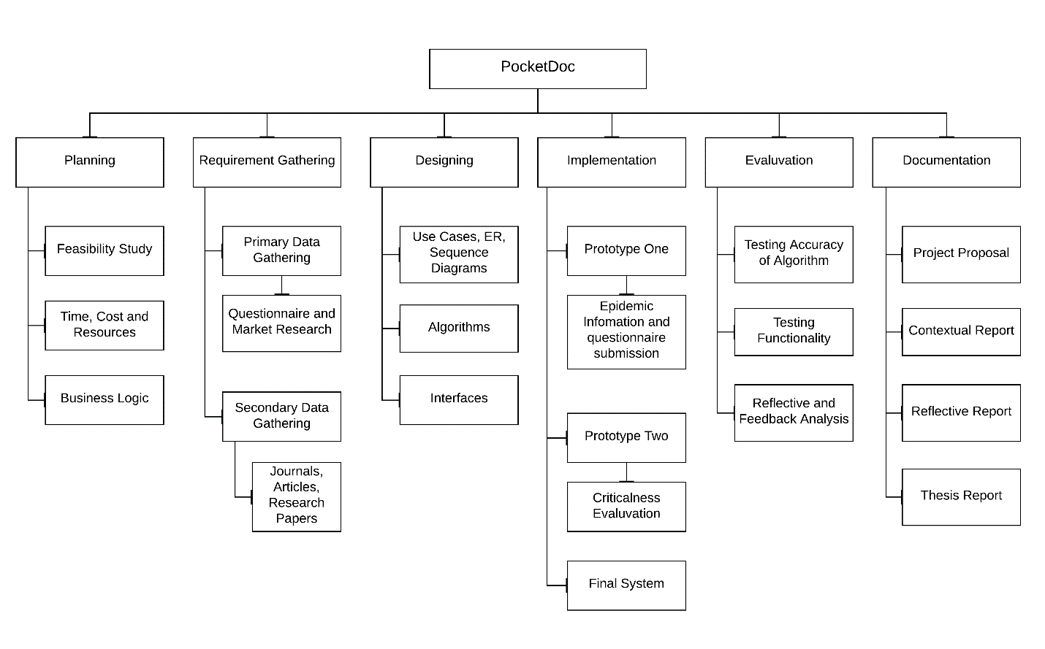

Gantt chart was created to keep track of the identified tasks and allocate time accordingly. Initially the Gantt chart was created relating to the delivery dates given in the module outline. However, completion of several tasks was not achieved according to the created timeline. The Gantt chart had a significant role in identifying which tasks absorbed less time and which tasks absorbed more time than expected. Later in the designing phase new Gantt was created adjusting according to the refactored timeline.



## **3.3 Requirement Analysis**

To develop the proposed system, primary and secondary research methodologies were used. A simple questionnaire was created to gather primary data from the random individuals aiming to determine their behavioral pattern during an outbreak. Secondary data regarding the history of Sri Lankan epidemics was gathered through research papers, websites and other publications made by reliable organizations.

### ***3.3.1 Primary Data Gathering***

Primary data gathering was mainly carried out to identify and determine the immediate responses of Sri Lankan citizens if they were found to be facing an epidemic. The survey has 109 responses from random individuals.

* Immediate response

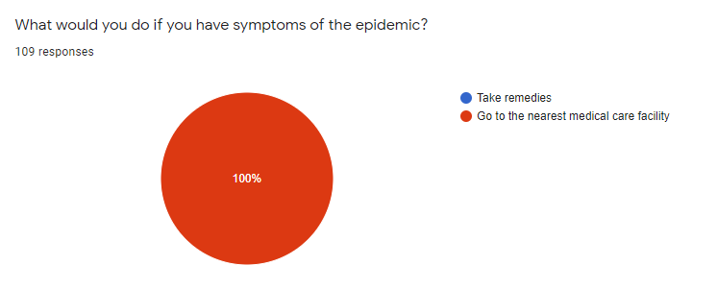

The responses received in regard to the question was quite catastrophic. 100% of individuals responded, they would attend the nearest medical institution regardless of the outbreak. Even with remote medical consultations provided by private organizations, people would still be visiting medical institutions for further consultation. This clearly indicates the significance of the proposed system and the benefits to the healthcare authority to overcome these circumstances.

* Precautionary measurements

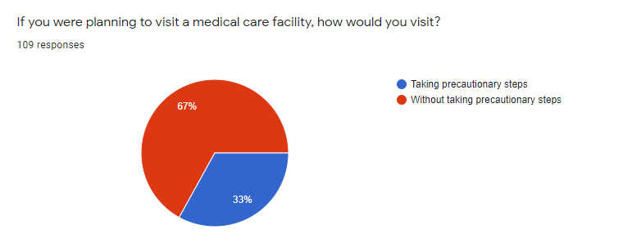

If an outbreak is in its early stages of infection, almost all citizens would be facing a threat of being exposed. In such situations, people rely on prevention materials to protect themselves and if that demand is not met by supply, people tend to panic. As per the conducted survey, 67% of the population act on their survival instinct and check into medical institutions without considering the risk factor. In such cases, the proposed system would provide a significant benefit for the healthcare authority to keep in contact with citizens and analyse their criticalness without having to expose medical staff to the risk of becoming infected.

* Proposed solution

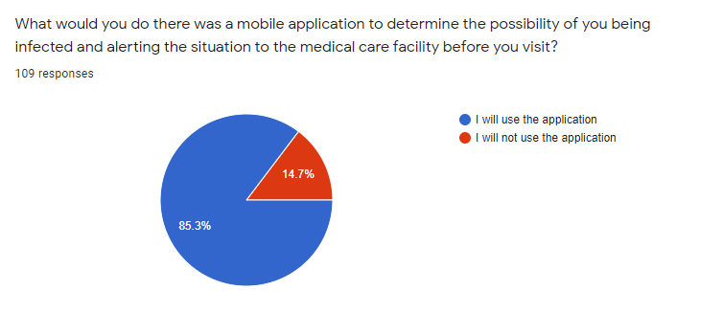

The proposed system will analyze the answers provided by each and every individual and determine their probability of whether the individual is infected or not. Conducted survey statistics indicates that 85% of the Sri Lankan population would be willing to use the proposed system to communicate with the healthcare authority directly and know if they have a chance of already being infected or not. The responses collected indicates that citizens would be willing to rely on such a system.

* Proposed solution with improved accuracy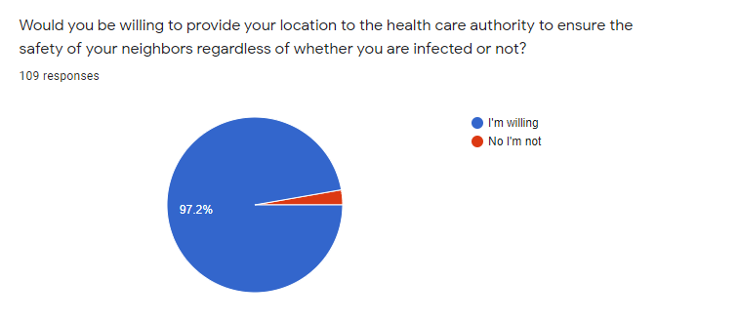

Responses indicate that 97.2% Sri Lankan general population would be willing to share their location when using the proposed system, rather than visiting a medical institution and increasing the chances of becoming infected.

* Other proposed services

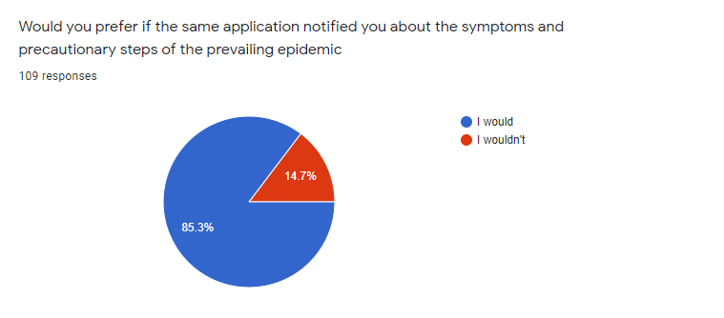

The market research indicates that 85.3% of Sri Lankan citizens would prefer to know the overall situation of the country. The service was only provided by one medical care application (NawalokaCare) in Chapter – 02, similar systems. As indicated by the market research, the proposed application would provide a significant upper hand in contributing to the wellbeing of Sri Lankan citizens.

## **3.4 Design**

### ***3.4.1 System design – Use case Diagram***

The use case diagram briefly demonstrates the overall functionality of the proposed system. Who, what and how the proposed system will be used is represented in the diagram.

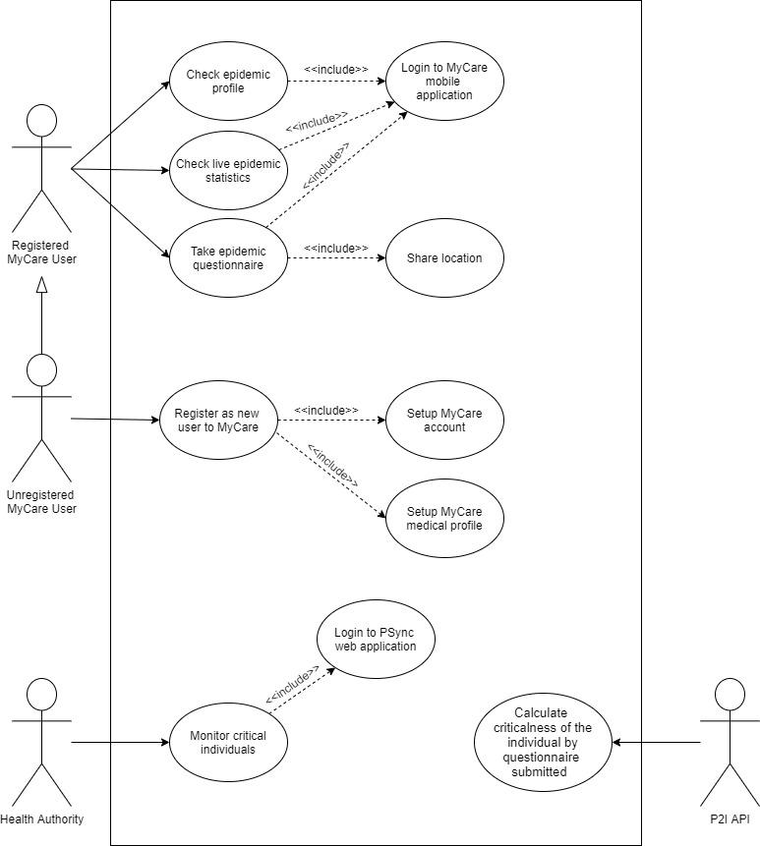

### ***3.4.2 System Designs – Authentication Flow Chart***

### ***3.4.3 System Designs – Questionnaire Submission Flow Chart***

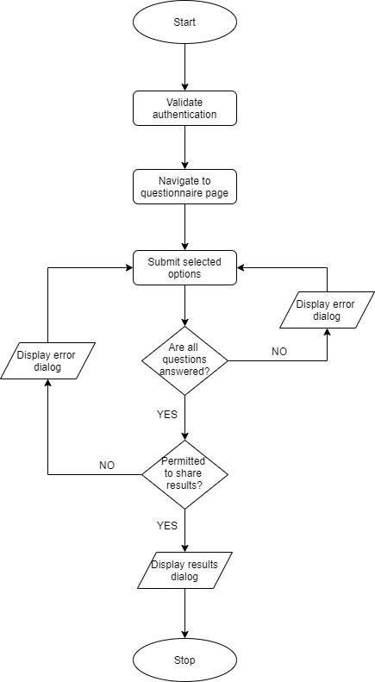

### ***3.4.4 System Designs – P2I Algorithm Flow Chart***

### ***3.4.5 System Designs – Sequence Diagram***

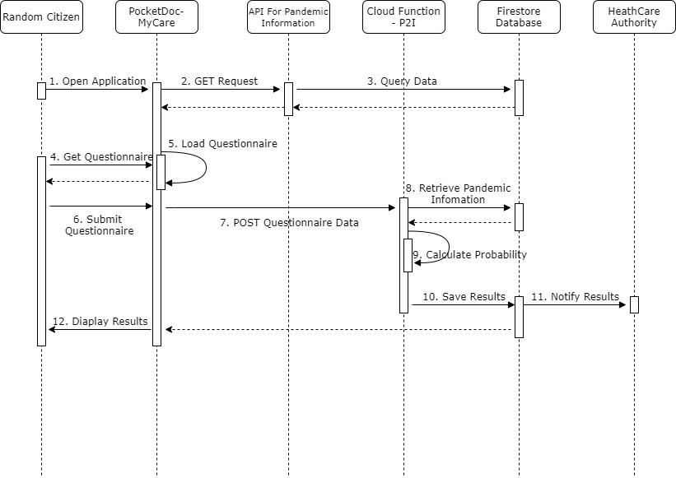

### ***3.4.6 System Designs – Data Model Diagram***

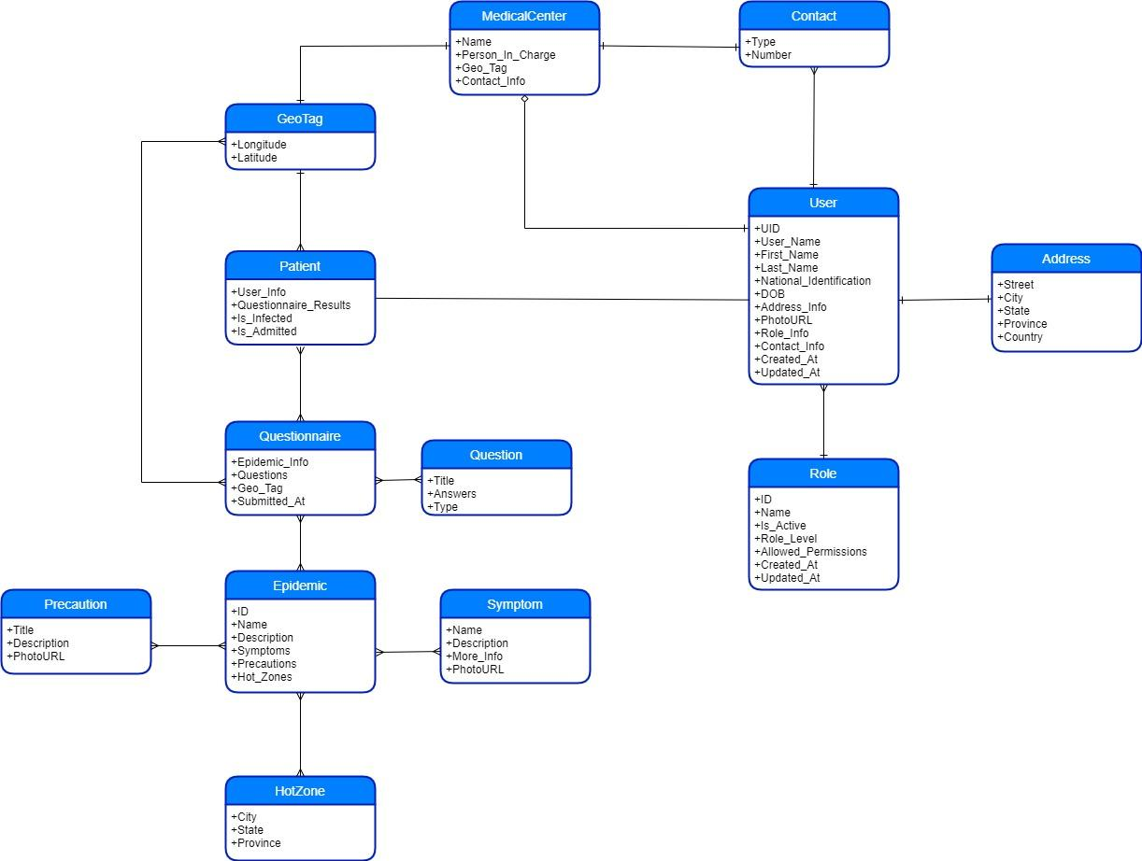

### ***3.4.7 High Level Architecture***

To obtain a more precise understanding of the proposed system, high level architecture was drawn. The purpose of the diagram was to determine how and what type of technical solutions were to be used to implement the proposed system.

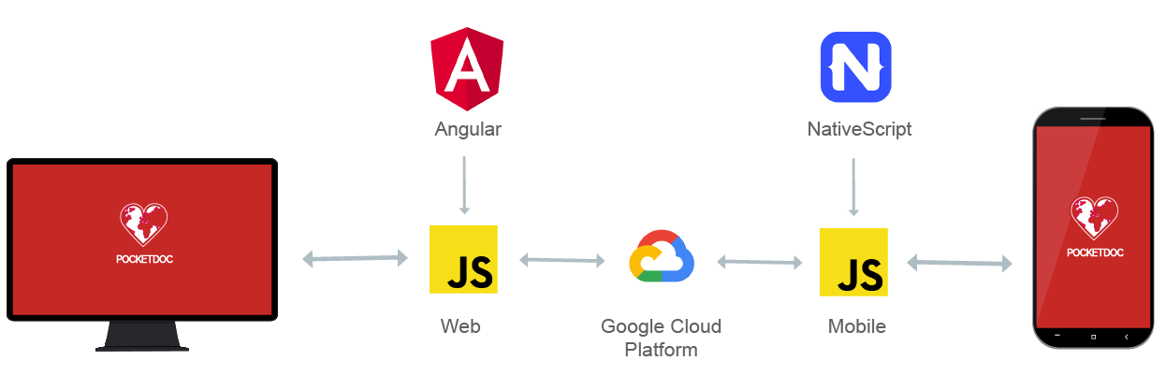

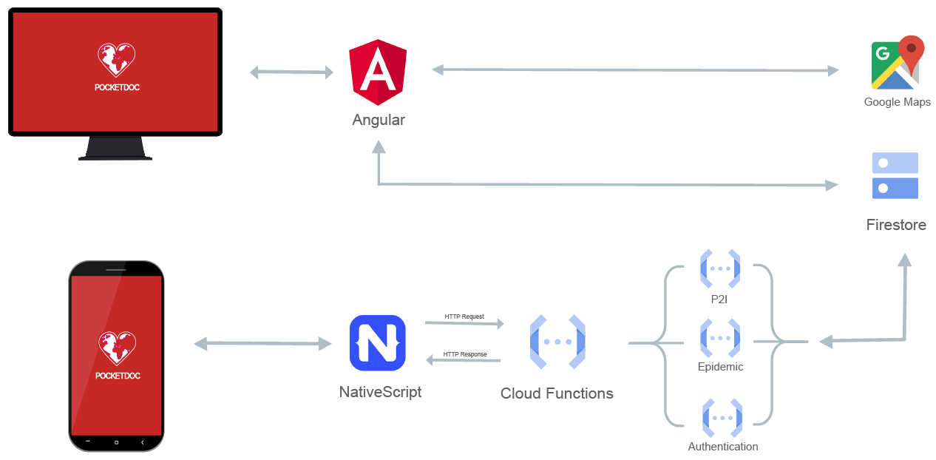

### ***3.4.8 Interfaces of the proposed system***

* PocketDoc - MyCare



* PocketDoc - PSync





## ***3.5 Implementation***

The chapter broadly illustrates the technologies used for the implementation and significant code segments of the proposed system. The proposed system contains a cross-platform mobile application, for the use of Sri Lankan citizens (PocketDoc-MyCare) and web application, for the healthcare authority (PocketDoc-PSync). PocketDoc-MyCare was developed using NativeScript and PocketDoc-PSync was developed using Angular.

### ***3.5.1 Technologies Used***

The proposed system was implemented with the use of several open source libraries, frameworks and services provided by third party vendors.

* Angular

Angular is a reactive frontend JavaScript framework used to build client applications using TypeScript, HTML, and CSS. Angular is a combination of both Model-View-Controller (MVC) and Model-View-ViewModel (MVVM) architectures, however it is most commonly known as a component-oriented architecture.

To implement PSync web application of the proposed system, Angular 10 was used. The reason behind selecting Angular was its architecture to build reusable components with increased complexity and object orientation provided by TypeScript. To dive deep into the MVC architecture, models represent the business logic, which help to retrieve and manipulate data from the database. Views represent the user interface, which the user interact with. Controllers can be defined as the middleware which connects the model with the view.

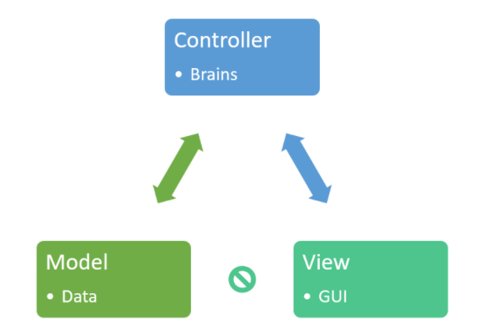

Once the user requests a page, the request will be handled by a controller, and this request is decoded by the controller. The controller then requests the required data from the database through a relevant model, structure data as required and finally render the appropriate view.

* NativeScript

NativeScript in an open source framework to build cross-platform applications using JavaScript. NativeScript offers a range of integration frameworks which includes Angular for mobile development. Once the implementation is completed in JavaScript, the build will take care of generating the native codes for each platform behind the scenes.

In order to implement MyCare mobile application of the proposed system, NativeScript along with Angular framework integration was used. The reason behind selecting NativeScript was that Angular was already selected for the web application and apart from the several different libraries, implementing the mobile application was quite similar to the web application.

To support Android development using NativeScript, Android SDK (API 29) was installed as a pre-requisite.

* GCP Services

Google Cloud Platform provides a variety of services and environments which helped to finalize the proposed system on time.

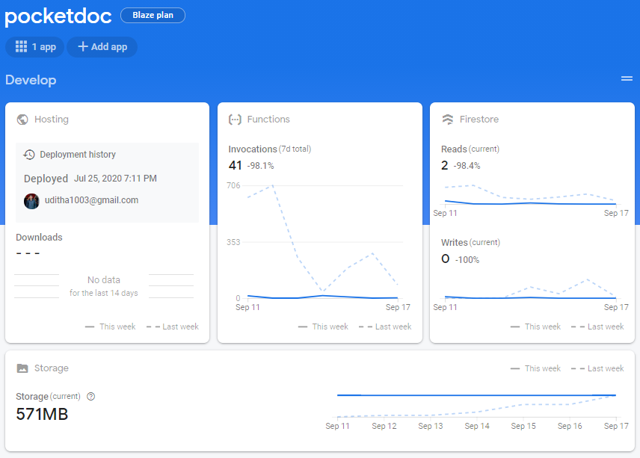

Figure 24: Firebase console of PocketDoc system

* + Cloud Firestore is a real-time NoSQL document-based database, which offers a variety of inbuilt functionalities to store, sync and query data without added complexity. Cloud Firestore was selected due to its real-time syncing nature, and NoSQL structure which meant JSON objects to structure data. This had a significant advantage when undergoing development with two JavaScript applications.

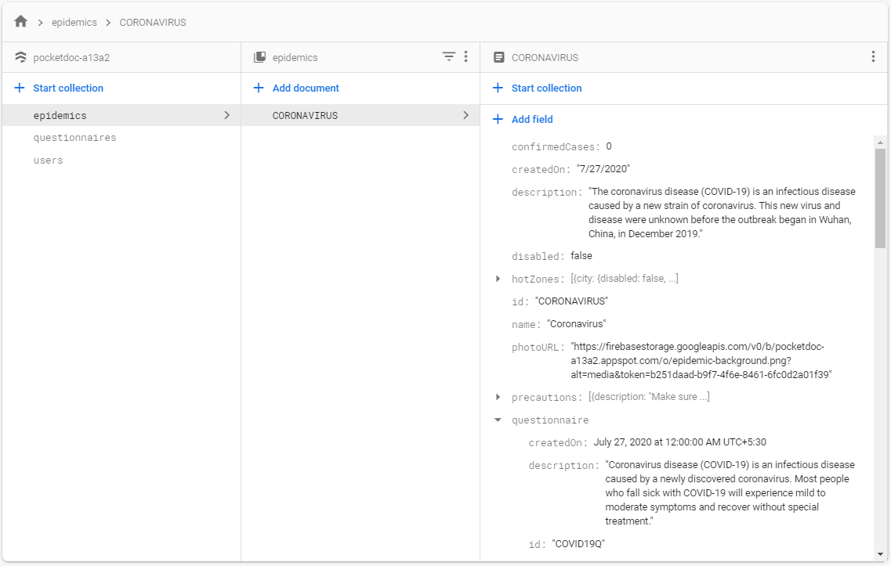

Figure 25 : Firestore database

* + Authentication is another on-the-go functionality provided by Firebase. It provides easy-to-use SDKs, backend services, and UI libraries to authenticate users into the application with just a couple of lines of code.
  + Cloud Functions are provided as a service for Firebase, which is a serverless framework that helps developers perform backend operations in response to event triggers such as HTTP requests.

Cloud Functions were selected due to its serverless framework, which helped to cut back on the implementation time along with improved backend security. Apart from running backend operations, Cloud Functions also has the capability to create REST APIs which was widely used throughout the PocketDoc-MyCare application to connect to the database.

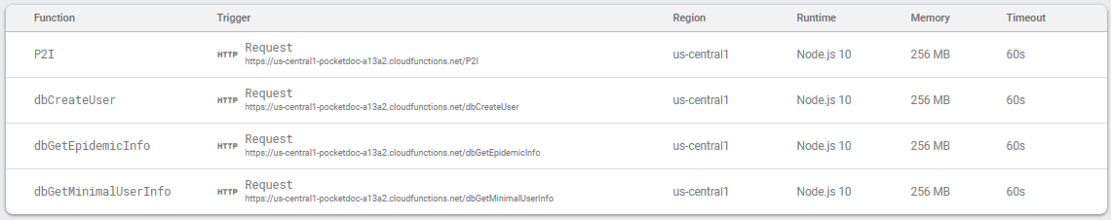

Figure 26 : Firebase Cloud Function dashboard

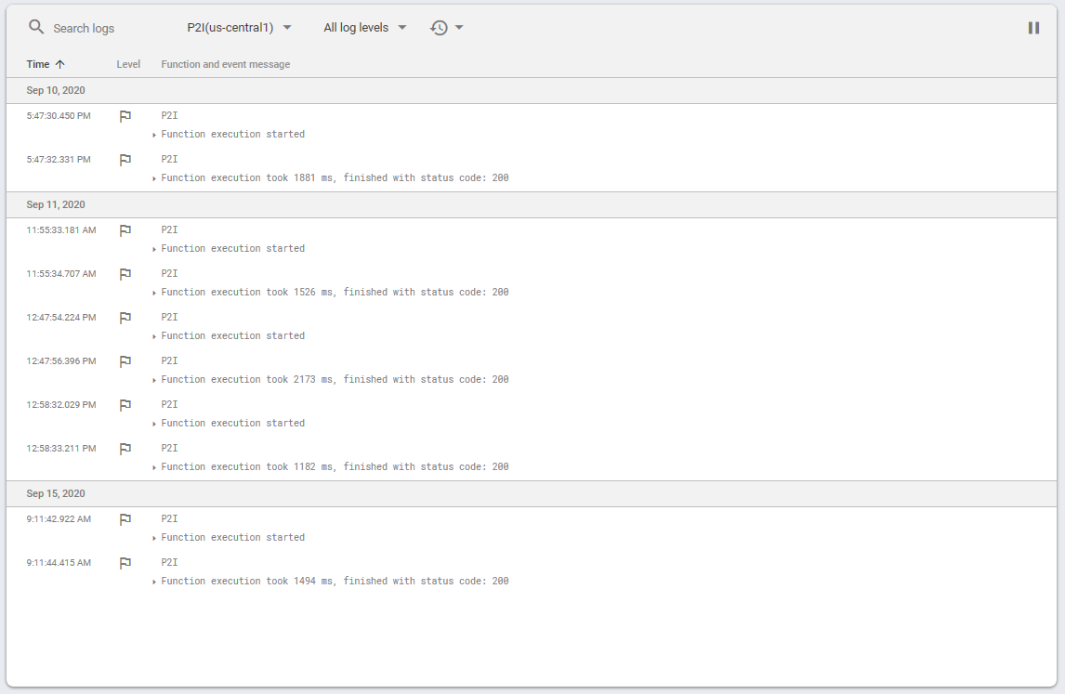

Figure 27 : Firebase Cloud Function console

* + Firebase Hosting provides a production-grade static web application hosting service for developers. Firebase Hosting was used to host the PocketDoc-PSync application.
  + Firebase also offers a storage services through Firebase storage. This service was used to store images that was used by both PocketDoc applications.

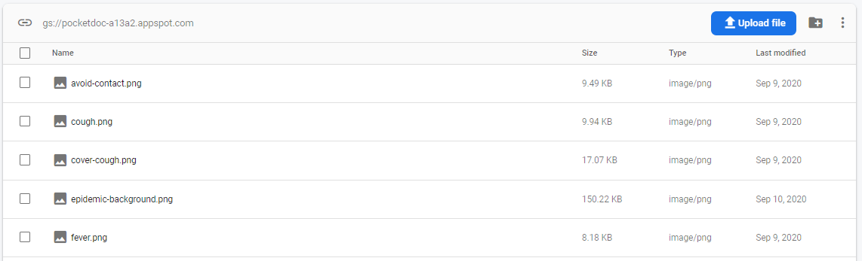

Figure 28 : Firebase Storage

* Visual Studio Code

Visual Studio Code is a high-performance light weight Integrated Development Environment (IDE) which was used to implement both PocketDoc-MyCare and PSync applications. Reason behind the selection was due to its various functionalities which helped the implementation process to be carried out much smoothly.

* GitHub

GitHub offers a number of services which includes distributed version control and source code management of Git. Git is an open source distributed version control system which helps to track source code changes when implementing a system.

GitHub was used to manage the source code, setup a continuous integration and continuous development (CI/CD) to deploy PocketDoc-PSync and to keep reference for future researchers.



### ***3.5.2 Code segments***

* Code segments of REST APIs

REST APIs were created using Firebase Cloud Functions to handle HTTP events.

* P2I API (Algorithm implemented on the API)

The P2I algorithm was implemented in a REST API to support its adaption through a variety of platforms and help other developers gain access to it.



The runtime environment was selected as Node.js 10 due to its efficiency and the ease of manipulating data through JSON objects.

Once the API is called, it will register the request type and it must be a POST request for the following steps to proceed, if not the response will be sent back as an ‘Unauthorized request’.

After the request type is validated then, will proceed with the validation of requested data. The request body must contain the user, questionnaire, and the epidemic MAPs (JavaScript Map) to process, if not response will be sent as a ‘Bad Request’.

Once the request body is validated, Firebase Admin SDK will reach to the Firestore database and retrieve the epidemic profile that the user has answered to. To avoid risk of data exposure and improve security the entire epidemic profile will not be sent to the user. This is the reason behind retrieving the entire epidemic profile again when the API is called.

After retrieving the epidemic profile, P2I algorithm will then run to calculate and determine the criticalness of the user.



Each question in the questionnaire is weighted which adds up to 100%. And each option inside a question is also weighted which adds up to 100% of that particular question. Following example is provided to gain a better understanding of how the criticalness of a user is determined.

A questionnaire has 2 questions. 1st question weights 80% and 2nd question weights 20%

Question 1 has 3 options. 1st option weights 50%, 2nd option weights 30%, and 3rd option weights 20%.  
Question 2 has 2 options. 1st option weights 60% and 2nd option weights 40%.

Assuming that request type and body is validated. The user selects, option 1 for the 1st question and option 2 for the 2nd question.  
  
The criticalness is calculated as:  
for 1st question, 50/100 x 80 = 40%  
for 2nd question, 60/100 x 20 = 24%

The criticalness of the user is 64%. All values below 80% is considered as non-critical thus will not be notified to the healthcare authority.

Once the criticalness is determined, algorithm will proceed to determine whether the user is located in an area categorized as a hot zone or not. Regardless of the of level of criticalness, if a user is located in an area categorized as a hot zone, healthcare authority will be notified.



Finally, after determining the user and location criticalness, the response will be sent back accordingly.



* Epidemic Profile API

When a user login to PocketDoc-MyCare application, GET request will be made to fetch the profile of the prevailing epidemic. The API implementation will then reach the Firestore database through Firebase Admin SDK and fetch the epidemic which has a status of active.



And when sending the response in regard to the API call, the entire epidemic profile will not be sent, rather, only a needed data will be sent. This is done to avoid the risk of questionnaire weightings been exposed and thereby improve the overall security of the system.



Process of extracting minimal data from the retrieved epidemic profile is carried out using custom implemented utility functions. Separate utility functions were implemented to improve the code reusability and readability.



* Fetch User Profile API

When a user login to PocketDoc-MyCare application, POST request will be made to fetch the profile of the signed in user. The API implementation will then reach the Firestore database through Firebase Admin SDK and fetch the user which matches the of signed in users email.

Once the request type and body are validated the process will then proceed on to locating the user document of the provided email address. If the user document if found the response will we sent back with a JSON object containing the user’s information, else relevant error response will be sent.



* CreateUser API

Once the user signup into PocketDoc, the second step is to setup a personal medical profile. This API was implemented to create a user document in the Firestore database for future references.



To extract data from the request body and generate a JSON object containing the required fields, extractUserInfo function was implemented. Functions accepts a parameter of type any which is then used to map data to a JSON object.



* Code segments for PocketDoc-MyCare

Service classes were implemented for the MyCare application reach the REST APIs and save state of ongoing operations.

* Auth service class

Auth service class handles operations related to authentication of the MyCare application. All connection made to the database were done through API calls to reduce in-app complexity and increase the level abstraction incase if alterations needs to be carried out without impacting the existing MyCare implementation.



* Epidemic service class

Epidemics service class controls operations of fetching the epidemic profile though the API and sending answered questionnaire to P2I API get the user criticalness.



* User service class

User service class is implemented to store state of the signed in user. The service should be injected / called when the MyCare boots up in order to save signed in user’s profile information.



* Questionnaire component



The above implementation determines whether all the questions has been answered, location services has been turned on and MyCare has permission to share results with the healthcare authority. If validation is successful, then the selected options will be sent to the P2I API and results will be displayed to the user through a native pop-up alert. If by any chance the validations fail, relevant error messages will be shown to the user though a native pop-up alert.

Layout of the questionnaire is implemented in a HTML file, but the content is implemented in XML format. The following was one of the most difficult implementations when MyCare application was being developed. Angular had released a new version (Angular 10) and the plugin which was supposed to be used to display radio buttons was not supported due to the early stage of Angular release. The implementation was in an irreversible stage; therefore, radio buttons was replaced by native platform buttons and its behavior was customized to match the behavior of a radio button.



* Login Component

Implementation of forms on MyCare had a significant learning curve. The reactive forms that were used in Angular web application was quite different from how it was implemented in NativeScript applications. Due to the unexpected learning curve the implementation of MyCare application took longer than expected. RadDataForms, a NativeScript UI component was used to display input fields and gather entered data from the users. To validate the credentials, Firebase SDK provides an inbuilt API to authenticate and sign in a user simply by calling the API and passing an existing email and a valid password. In return the Firebase returns a secure token to be used in storing data onto Firestore.



The layout for the login screen with the use of RadDataForm for obtaining user credentials and validating provided values real-time.

* Signup Component

Firebase SDK provides an inbuilt API to create a Firebase account by simply calling the API and passing a valid email and a password which has more than 6 characters to it. In return the Firebase returns a unique user id, account email and a secure token to be used in storing data onto Firestore. Once the account is created, user’s email and unique user id is stored in a state to proceed with the creation of medical profile.



The second step is to setup the personal medial profile. To create the profile, custom API was implemented. Once the data the user has provided has been validated CreateUser API will be called and profile data will be sent as a POST request.



* Code segments for PocketDoc-PSync

Implementation of PSync application included the functionality to monitor and locate potentially infected individuals based on the submitted questionnaires.

* Mapping individuals who has a high probability of being infected

To locate the potentially infected individual though Google Maps, separate API key was generated through GCP and a reusable Angular component was created.



# **4. Results and Discussion**

## **4.1 Structure of Testing**

To identify and address the bugs of the proposed system, several testing methodologies were used. Unit testing was carried out by dividing the overall system into small chunks and then testing them individually. With each completed unit test, the chunk was merged with its relevant sub functionalities. Once the unit testing was finalized, integration testing was carried out to address the issues occurred during the merging process. After both unit testing and integration testing was finalized, system testing was carried out to evaluate the compliance with the requirements

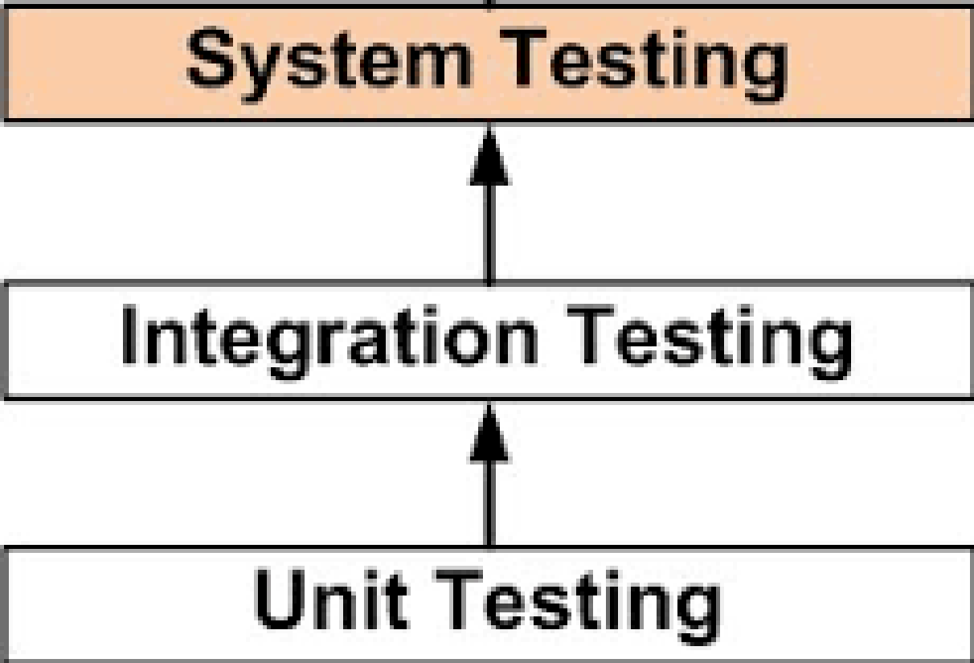

## **4.2 Testing Methods Used**

In order to precisely identify system bugs and issues, several types testing methodologies were used to cover each phase of testing.

* Unit testing – White Box testing
* Integration Testing – Black box testing
* System testing – Black box testing

## **4.3 Test Plan and Test Cases**

Accuracy of the proposed system was determined though the test cases conducted. The proposed system was rated over 80% on its accuracy. To properly organize and manage the testing phase of the proposed system, following test plans were created.

Table 2 : Test plans

|  |  |  |
| --- | --- | --- |
| No | Area | Description |
| 1 | PocketDoc-MyCare user registration | Checking for the validation of user creation and setting up of medical profile |
| 2 | PocketDoc-MyCare user login | Checking for the validation of user login. |
| 3 | Questionnaire submission and P2I algorithm validation | Checking for the validation of questionnaire submission and outcome of analyzed results |
| 4 | PocketDoc-MyCare user logout | Checking for the validation of removal of state on user logout |
| 5 | P2I algorithm availability | Checking for the availability of P2I API for other researcher and developers |
| 6 | PocketDoc-PSync mapping potentially infected | Checking the functionality to locate a potentially infected individual |

Table 3 : PocketDoc test cases

|  |  |
| --- | --- |
| Test Case | 1.0 |
| Description | To create a new account with PocketDoc:   1. Enter new valid email (should include @, .) 2. Enter password with more than 6 characters 3. Click “Create Account” button |
| Input Values | Email : [uditha@pocketdoc.com](mailto:uditha@pocketdoc.com) Password : pocketdoc123 |
| Expected Output | Success dialog should be displayed with content as “account created” |
| Actual Output |  |
| Result | Pass |
| Test Case | 1.1 |
| Description | To validate user entered email against existing PocketDoc accounts:   1. Enter existing email 2. Enter password with more than 6 characters 3. Click “Create Account” button |
| Input Values | Email : [udaya@pocketdoc.com](mailto:udaya@pocketdoc.com) Password : pocketdoc123 |
| Expected Output | Error dialog should be displayed with content as “existing email” |
| Actual Output |  |
| Result | Pass |
| Test Case | 1.2 |
| Description | To create a medial profile on PocketDoc:   1. Enter first name, last name, date of birth, national identification number (Sri Lanka), city contact number 2. Accept to share medial profile 3. Click “Create Profile” button |
| Input Values | First name : Uditha Last name : Silva  Date of Birth : 02/25/1996  National Identification number : 960563504v  City : Katunayake  Contact Number : +94770798025 |
| Expected Output | Success dialog should be displayed with content as “profile created” |
| Actual Output |  |
| Result | Pass |
| Test Case | 2.0 |
| Description | To login to MyCare app using valid credentials:   1. Enter valid email (should include @, .) 2. Enter valid password with more than 6 characters 3. Click “Sign In” button |
| Input Values | Email : [uditha@pocketdoc.com](mailto:uditha@pocketdoc.com) Password : pocketdoc123 |
| Expected Output | User should be navigated to home page (epidemic profile page) |
| Actual Output |  |
| Result | Pass |
| Test Case | 2.1 |
| Description | To login to MyCare app using invalid credentials:   1. Enter email of valid format (should include @, .) 2. Enter password of valid format (6 characters min) 3. Click “Sign In” button |
| Input Values | Email : [uditha123@pocketdoc.com](mailto:uditha123@pocketdoc.com) Password : pocketdoc123 |
| Expected Output | Error dialog should be displayed with content as “invalid credentials” |
| Actual Output |  |
| Result | Pass |
| Test Case | 3.0 |
| Description | To submit questionnaire without selecting options for all questions:   1. Select options for several but not all questions 2. Click “Submit” button |
| Input Values | None |
| Expected Output | Error dialog should be displayed with content as “answers for all questions must be selected” |
| Actual Output |  |
| Result | Pass |
| Test Case | 3.1 |
| Description | To submit questionnaire after selecting options for all questions:   1. Select options all questions 2. Click “Submit” button |
| Input Values | None |
| Expected Output | Confirm dialog should be displayed with content as “Would you be willing to share questionnaire results” |
| Actual Output |  |
| Result | Pass |
| Test Case | 3.2 |
| Description | To submit questionnaire by selecting “YES” to share results:   1. Select options all questions 2. Click “Submit” button 3. Click “YES” to share results |
| Input Values | None |
| Expected Output | Alert dialog should be displayed with content as the results of user’s submitted questionnaire |
| Actual Output |  |
| Result | Pass |
| Test Case | 3.3 |
| Description | To submit questionnaire by selecting “NO” to share results:   1. Select options all questions 2. Click “Submit” button 3. Click “NO” to share results |
| Input Values | None |
| Expected Output | Error dialog should be displayed with content as the as “location must be shared to submit questionnaire” |
| Actual Output |  |
| Result | Pass |
| Test Case | 4.0 |
| Description | To sign out from MyCare app:   1. Open side drawer by clicking menu icon on top left 2. Click “Exit” to sign out |
| Input Values | None |
| Expected Output | User should be navigated back to sign in page after signing out |
| Actual Output |  |
| Result | Pass |

|  |  |
| --- | --- |
| Test Case | 5.0 |
| Description | To access P2I API for use of other platforms:   1. Visit <https://reqbin.com/> from any browser |
| Input Values | Request type : POST  Request URL : <https://us-central1-pocketdoc-a13a2.cloudfunctions.net/P2I>  Content type : JSON  Example dataset :  {  "questionnaire" : {  "questions" : [  {  "id" : "Q1",  "option" : "O2"  },  {  "id" : "Q2",  "option" : "O2"  }  ]  },  "epidemic" : {  "id" : "CORONAVIRUS"  },  "user" : {  "email" : "uditha.ethige@study.beds.ac.uk",  "addressInfo" : {  "city" : {  "id" : "MALABE"  }  }  }  } |
| Expected Output | Response should be received as a JSON object containing the status of request as “true” and result as “You do not have a probability of being infected, However, you are located in an area where significant number infected individuals has been found. Please stay indoors and take necessary precautions. Health authority will contact you shortly to verify your health condition” |
| Actual Output |  |
| Result | Pass |

|  |  |
| --- | --- |
| Test Case | 6.0 |
| Description | Once the user has submitted the questionnaire and P2I algorithm flags him/her as a potentially infected individual |
| Input Values | None |
| Expected Output | Once the Potentially infected individual has been flagged the coordinates should be mapped on the PSync dashboard to be reviewed by healthcare authority |
| Actual Output |  |
| Result | Pass |

# **5. Evaluation**

To proceed with evaluation, the proposed system was presented to two groups of people. Group one represented the citizens of Sri Lanka and had access to the PocketDoc-MyCare mobile application. Second group represented the healthcare authority of Sri Lanka and had access to PocketDoc-PSync web application. When conducting the evaluation of MyCare application, some obstacles were faced since the application was not deployed to Google Play Store. To overcome the obstacle, application was shared as an APK among selected individuals prior to the evaluation. Evaluation of PSync application was carried out smoothly since it was hosted with Firebase Hosting. Individuals of both parties were given necessary instructions while operating the assigned application. Once the evaluation was finalized, two surveys were conducted representing each party to collect feedback. Rating based approach was taken to conduct the survey and participants were instructed to rate from 1 to 10, were 1 being unacceptable and 10 being highly recommended. The completion of overall evaluation process took 4 days in total.

Groups participated in the evaluation process

* Group one was represent by 10 colleagues from University of Bedfordshire, 8 colleagues from Sri Lankan Institute of Information Technology and 5 randomly selected individuals
* Group two was represented by 12 4th year medical students from the University of Colombo, Sri Lanka.

Participated colleagues were instructed to provide an unbiased opinion in the feedback.

# **5.1 Evaluation Overview**

### ***5.1.1 Survey Overview of PocketDoc-MyCare***

Based on the conducted survey relating to PocketDoc-MyCare, following data were analyzed

Participants from UOB, SLIIT and randomly selected individuals gave an overall positive feedback on regarding the interfaces of the application. Randomly selected individuals preferred the user interfaces more than the others and stated that “it was understandable”. Most of the participants stated that the “flow of the system was too easy, and it made them feel quite unsure about its authenticity”. Participants from UOB and SLIIT preferred more information on the epidemic , however randomly selected individuals were quite satisfied. Authentication included sign in, sign up and setting up of medical profile. Both UOB and SLIIT participants preferred the flow but randomly selected individuals stated that “it was too much work”. All parties were pleased with how the answering of the questionnaire was carried out. UOB and SLIIT participants stated that “horizontal scrolling when selecting an answer was quite satisfying and was a new experience for them”. Questionnaire results and its efficiency was noted by all participants and was pleased. However, SLIIT and UOB participants stated that the “way the outcome was presented could be improved to make the users feel that it was authentic”. All parties were pleased with the overall efficiency of the application. SLIIT and randomly selected participants preferred the application more than the UOB participants and stated that “it was clear, and colors were matching”. UOB participants states that “change of color theme would increase the user friendless”.

### ***5.1.2 Survey Overview of PocketDoc-PSync***

Based on the conducted survey relating to PocketDoc-PSync, following data were analyzed.

Survey of PocketDoc-PSync was conducted though 4th year medial students. Based on the survey, participants gave an overall positive feedback. The participants stated that “the proposed system had potential and approach was a good approach to the issue in hand”. The participants had difficulty in grasping the flow of the system initially which represents the overall feedback of 5 for flow of the system.

# **6. Conclusion**

## **6.1 Conclusion**

The proposed system PocketDoc was implemented to help lay the foundation for a technological platform that connected citizens of Sri Lanka and the healthcare authority in time of an epidemic. Core belief of the proposed system was, by bridging the gap between these two parties in time on an epidemic, the risk of virus exposed to medical staff and other citizens would be reduced. Thereby reducing the escalation of the virus. The proposed system initially had 6 core objectives and after inspecting the evaluation reports, it could be determined that 80% of the overall system was completed with successfully achieving its objective. The outcome of the evaluation process revealed additional implementation which could have increased the value of the system, but however, these implementations were not pursued due to the time constraint.

## **6.2 Lessons Learned**

During the implementation phase, a remarkable amount of skills, knowledge and experience was gathered. To help ease the implementation process, tasks of the proposed system were identified and divided into chunks. To complete each chunk with the allocated time was challenging and I gained more and more personal growth with completion of each chunk. The learning curve of the proposed system was quite high, I had no prior knowledge of mobile development and to mention that not only was I planning to develop a mobile application but also make it a cross-platform one. Internship experience on working with Angular framework was a significant upper hand in implementing both the web and mobile applications. Building serverless applications was an entirely new learning curve. Commitment towards identifying required technologies, researching them, and performing feasibility studies personally helped me to gain more knowledge and experience about the software engineering industry that I had no prior knowledge of. Implementation of the proposed system helped me to understand how powerful a framework can be once properly understood. Angular’s component-oriented architecture saved a significant amount of time which helped to finalize the system on schedule. The major setback faced was the Angular 10 release. The release made almost all third-party libraries which were integrated into the mobile application unstable and I had to invest a deep amount of time researching for alternative methods to proceed. And the two major lessons learned was not to take time for granted and conduct a deep research on technologies before start implementing right away. Implementation phase was the most time-consuming phase. With learning and implementing Angular framework and building a cross-platform mobile application from the scratch, initially allocated time was not nearly enough. Input received from the medical students made a huge impact in the creation of the algorithm and determining the way information should be handled. Even though I had no medical expertise of any kind, discussing the proposed system with medical students gave me experience and insight on how much risk they were exposed to in times of an epidemic.

## **6.3 Limitations**

As stated in the conclusion, 80% of the overall system was successfully completed while meeting mentioned objectives. As from the initial planning phase there were several complications made reaching 100% quite impossible.

The major limitation was that, though it was decided to build a cross-platform mobile application, running, and performing tests on IOS platform was impossible due to lack of proper resources. Another limitation was that location of the PocketDoc-MyCare users were determined only through a dropdown menu which showed all the cities and asked them to select the city that they were presently located in. This was due to the purchasing of Google’s Geolocation API was quite expensive.

Furthermore, the proposed system was planned to undergo beta and alpha testing for a better evaluation. Due to the delay of time schedules with the development phase, the proposed system was not able to complete these testing phases. Even though the proposed system was evaluated by medical students and randomly selected Sri Lankan citizens, to determine the level of accuracy, more deeper testing must be carried out.

## **6.4 Future Work**

As for the future of the proposed system, the remaining 20% of the system which was unable to complete due to the time constraints should be finalized. After finalizing the system, acceptance testing should be carried out again and results should be evaluated before proceeding with further modification.

Lack of real-time geo location of the PocketDoc-MyCare users is a major setback. For future work Google’s Geolocation API can be integrated into the application to improve the accuracy of the results.

Another major future implementation would be, firstly, installing monitoring devices to medical institutions. Secondly, improving implementation on PocketDoc-MyCare devices to capture an individual's face while submitting the questionnaire. And finally, feeding the image to a face recognition algorithm and actively running it through monitoring devices on medical institutions and alerting if he/she arrives. This would help the medical staff take necessary precautions and stop the virus spreading throughout the medical institution.

Apart from the use of monitoring devices, a similar outcome could be achieved though geo fencing technology. This could be done by registering geo coordinates of each and every medical institution and using cell towers to locate PocketDoc-MyCare users at all times. In an individual with a high probability of being infected steps inside the radius on any registered geo coordinate the institution will be alerted.

# **References**

2020. *Communicable Disease Epidemiological Profile Sri Lanka*. [ebook] World Health Organization. Available at: <https://www.who.int> [Accessed 15 May 2020].

2020. *Coronavirus Disease 2019 (COVID-19) - Situation Report – 24.05.2020 – 10.00Am*. [ebook] Epidemiology Unit Ministry of Health & Indigenous Medical Services, p.2. Available at: <http://www.epid.gov.lk/web/index.php?option=com_content&view=article&id=225&Itemid=518&lang=en> [Accessed 24 May 2020].

2020. *Doc 990*. [image] Available at: <https://play.google.com/store/apps/details?id=com.inova.velocity&hl=en> [Accessed 16 September 2020].

2020. *Echanneling*. [image] Available at: <https://lh3.googleusercontent.com/sbmZyljbYq30StC7fHQEbROBG3tK3QwkCi8HLpj7jIujtwg6zxSwCL6w32NhH3LSwPM=w1920-h937-rw> [Accessed 25 May 2020].

2020. *Echannelling*. [image] Available at: <https://play.google.com/store/apps/details?id=com.echannelling.mobilechannelling&hl=en> [Accessed 16 September 2020].

2020. *Nawalokacare*. [image] Available at: <https://play.google.com/store/apps/details?id=com.health_assist&hl=en> [Accessed 16 September 2020].

2020. *Odoc*. [image] Available at: <https://lh3.googleusercontent.com/j5mj_IN86QfiHnP3pCeB08bEnh6WGkk0puT1kx1h5qC6BlbWMosV2puT0VU0vTpw-w=w1920-h937-rw> [Accessed 25 May 2020].

2020. *Odoc*. [image] Available at: <https://play.google.com/store/apps/details?id=com.developer.odoc&hl=en> [Accessed 16 September 2020].

2020. *Prototype Model*. [image] Available at: <https://www.researchgate.net/profile/Sri_Letsoin/publication/313786662/figure/fig1/AS:462414580850689@1487259635330/Prototype-Model-3.png> [Accessed 17 September 2020].

2020. *Prototyping Model*. [image] Available at: <https://www.guru99.com/images/1/051719_0618_Prototyping1.png> [Accessed 25 May 2020].

Cdc.gov. 2020. *Chikungunya Virus | CDC*. [online] Available at: <https://www.cdc.gov/chikungunya/index.html> [Accessed 24 May 2020].

Cdc.gov. 2020. *Dengue | CDC*. [online] Available at: <https://www.cdc.gov/dengue/index.html> [Accessed 25 May 2020].

Centers for Disease Control and Prevention. 2020. *Coronavirus Disease (COVID-19)*. [online] Available at: <https://www.cdc.gov/media/dpk/diseases-and-conditions/coronavirus/coronavirus-2020.html> [Accessed 25 May 2020].

Educative: Interactive Courses for Software Developers. 2020. *MVC Architecture In 5 Minutes: A Tutorial For Beginners*. [online] Available at: <https://www.educative.io/blog/mvc-tutorial> [Accessed 18 September 2020].

En.wikipedia.org. 2020. *Google Cloud Platform*. [online] Available at: <https://en.wikipedia.org/wiki/Google_Cloud_Platform> [Accessed 16 September 2020].

GeeksforGeeks. 2020. *Software Engineering | Prototyping Model - Geeksforgeeks*. [online] Available at: <https://www.geeksforgeeks.org/software-engineering-prototyping-model/> [Accessed 25 May 2020].

Hpb.health.gov.lk. 2020. *Coronavirus (COVID-19) Sri Lanka - Analytics Dashboard*. [online] Available at: <https://hpb.health.gov.lk/covid19-dashboard/> [Accessed 25 May 2020].

Hpb.health.gov.lk. 2020. *Rolling Updates On Coronavirus Disease (COVID-19)*. [online] Available at: <https://hpb.health.gov.lk/en/covid-19> [Accessed 25 May 2020].

Software Testing Fundamentals. 2020. *Black Box Testing - Software Testing Fundamentals*. [online] Available at: <http://softwaretestingfundamentals.com/black-box-testing/> [Accessed 25 May 2020].

Software Testing Fundamentals. 2020. *White Box Testing - Software Testing Fundamentals*. [online] Available at: <http://softwaretestingfundamentals.com/white-box-testing/> [Accessed 25 May 2020].

T, N., 2020. *What Is Prototyping Model? Phases, Types, Advantages & Disadvantages - Binary Terms*. [online] Binary Terms. Available at: <https://binaryterms.com/prototyping-model.html> [Accessed 17 September 2020].

Who.int. 2020. *WHO | Definitions: Emergencies*. [online] Available at: <https://www.who.int/hac/about/definitions/en/> [Accessed 21 May 2020].

Worldometers.info. 2020. *Sri Lanka Population (2020) - Worldometer*. [online] Available at: <https://www.worldometers.info/world-population/sri-lanka-population/> [Accessed 24 May 2020].

# **Appendix A – Project Poster**

# **Appendix B – Evaluation forms (MyCare & PSync)**

**MyCare Application**

Please be kind enough to provide feedback on PocketDoc-MyCare so that we can move with a better understanding and requirements of the existing features.

|  |  |  |  |  |
| --- | --- | --- | --- | --- |
| Functions &  Functionalities | Very Satisfied | Satisfied | Average | Poor |
| Interfaces of the application |  |  |  |  |
| Flow of the system |  |  |  |  |
| Overview of epidemic profile |  |  |  |  |
| Authentication |  |  |  |  |
| Answering the questionnaire |  |  |  |  |
| Questionnaire results |  |  |  |  |
| Efficiency |  |  |  |  |
| User friendliness |  |  |  |  |

1. Highly Satisfied = 10

2. Satisfied = 8

3. Average = 5

4. Poor = less than

**PSync Application**

Please be kind enough to provide feedback on PocketDoc-PSync application so that we can move with a better understanding and requirements of the existing features.

|  |  |  |  |  |
| --- | --- | --- | --- | --- |
| Functions &  Functionalities | Very Satisfied | Satisfied | Average | Poor |
| Interfaces of the application |  |  |  |  |
| Flow of the system |  |  |  |  |
| Overview of critical individuals |  |  |  |  |
| Mapping of potentially infected individuals |  |  |  |  |
| Efficiency |  |  |  |  |
| User friendliness |  |  |  |  |

1. Highly Satisfied = 10

2. Satisfied = 8

3. Average = 5

4. Poor = less than

# **Appendix C : Questionnaire**

As a final year undergraduate at the University of Bedfordshire,

currently, I am focused on developing a mobile application that will help to improve the survival chances of both medical staff and individuals in an epidemic.

Please spare a few moments to complete the questionnaire to help improve the chances of survival in times of an epidemic.

1.What would you do if you have symptoms of the epidemic?

A. Take remedies

B. Go to the nearest medical care facility

2. If you were to take remedies, would not you risk your family members getting

infected?

A. Yes

B. No

3. If you were planning to visit a medical care facility, how would you visit? *

A. Taking precautionary steps

B. Without taking precautionary steps

4. If you were to visit a medical care facility without taking precautionary steps, What

would be the possible outcome?

A. You endanger the individuals engaged in the transportation

B. You endanger the medial staff and other patients

C. Both of the above

5. What would you do there was a mobile application to determine the possibility of

you are being infected and alerting the situation to the medical care facility before

you visit?

1. I will use the application

B. I will not use the application

6. Would you be willing to provide your location to the health care authority to ensure

the safety of your neighbors regardless of whether you are infected or not? *

A. I am willing

B. No I am not

7.Would you prefer if the same application notified you about the symptoms and

precautionary steps of the prevailing epidemic

A. I would

B. I would not